**Solution: Plotting Triangles and Circles**

#Snippet producing the triangle-based plot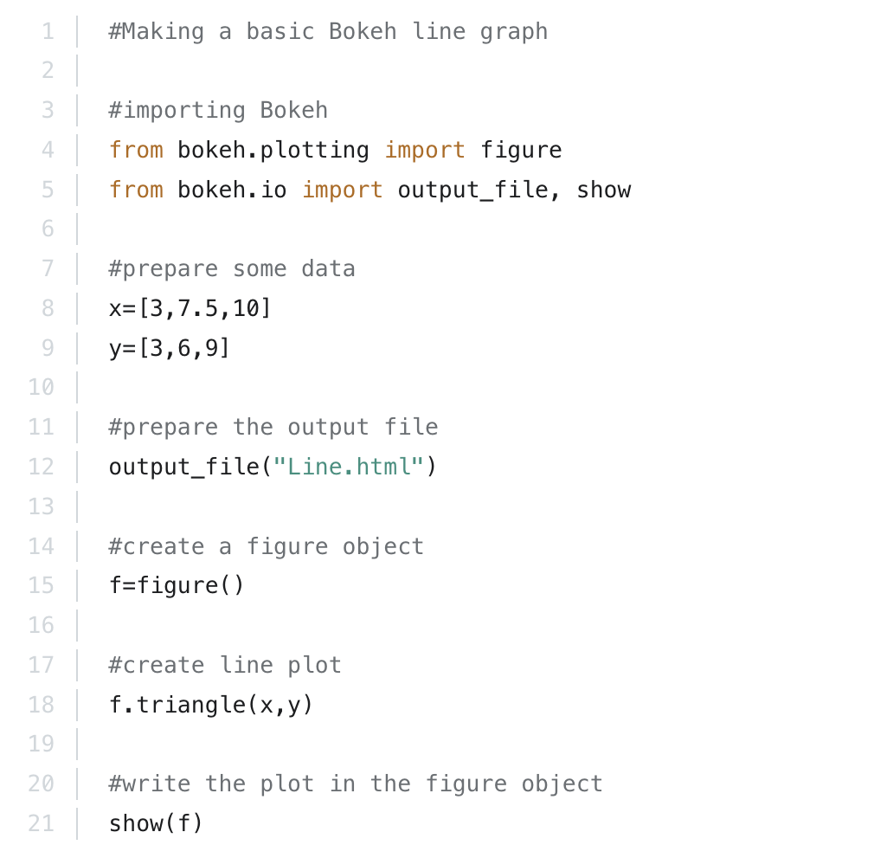

#Snippet producing the circle based plot